# Dis-Eur-GDR- Hohle Fels Cave-Venus Figurine-35-40 kyBP

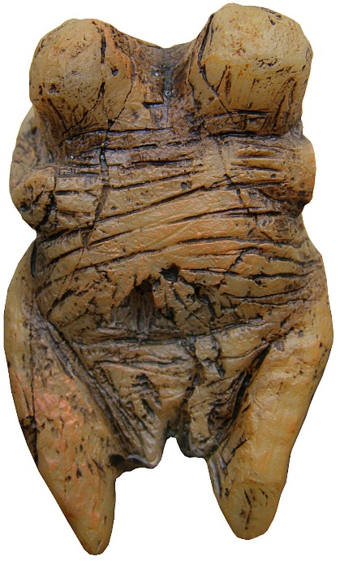 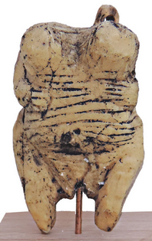 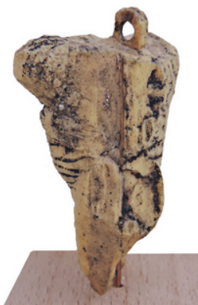 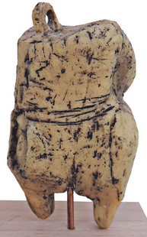 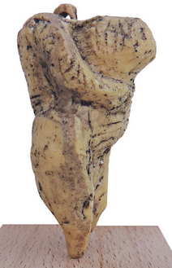

6 cm (2,4 inches)

The **Venus of Hohle Fels** (also known as the **Venus of Schelklingen**; in [German](http://en.wikipedia.org/wiki/German_language) variously *Venus vom Hohlen Fels, vom Hohle Fels; Venus von Schelklingen*) is an [Upper Paleolithic](http://en.wikipedia.org/wiki/Upper_Paleolithic) [Venus figurine](http://en.wikipedia.org/wiki/Venus_figurines) [hewn from i v o r y](http://en.wikipedia.org/wiki/Ivory_carving) of a [mammoth](http://en.wikipedia.org/wiki/Mammoth) [tusk](http://en.wikipedia.org/wiki/Tusk) found in 2008 near [Schelklingen](http://en.wikipedia.org/wiki/Schelklingen), [Germany](http://en.wikipedia.org/wiki/Germany). It is dated to between 35,000 and 40,000 years ago, belonging to the early [Aurignacian](http://en.wikipedia.org/wiki/Aurignacian), at the very beginning of the [Upper Paleolithic](http://en.wikipedia.org/wiki/Upper_Paleolithic), which is associated with the assumed earliest presence of [*Homo sapiens*](http://en.wikipedia.org/wiki/Homo_sapiens) in [Europe](http://en.wikipedia.org/wiki/Paleolithic_Europe) ([Cro-Magnon](http://en.wikipedia.org/wiki/Cro-Magnon)). It is the oldest undisputed example of [Upper Paleolithic art](http://en.wikipedia.org/wiki/Art_of_the_Upper_Paleolithic) and [figurative](http://en.wikipedia.org/wiki/Figurative_art) [prehistoric art](http://en.wikipedia.org/wiki/Prehistoric_art) in general. In 2011, the figure is still being researched in the [University of Tübingen](http://en.wikipedia.org/wiki/University_of_T%C3%BCbingen), though there are plans to house it and other discoveries from the region in a planned new museum in [Swabia](http://en.wikipedia.org/wiki/Swabia).[[1]](http://en.wikipedia.org/wiki/Venus_of_Hohle_Fels#cite_note-1)

|  |
| --- |
| Contents  * [1 Context](http://en.wikipedia.org/wiki/Venus_of_Hohle_Fels#Context) * [2 Discovery](http://en.wikipedia.org/wiki/Venus_of_Hohle_Fels#Discovery) * [3 Description](http://en.wikipedia.org/wiki/Venus_of_Hohle_Fels#Description) * [4 See also](http://en.wikipedia.org/wiki/Venus_of_Hohle_Fels#See_also) * [5 Notes and references](http://en.wikipedia.org/wiki/Venus_of_Hohle_Fels#Notes_and_references) * [6 Further reading](http://en.wikipedia.org/wiki/Venus_of_Hohle_Fels#Further_reading) * [7 External links](http://en.wikipedia.org/wiki/Venus_of_Hohle_Fels#External_links) |

## Context

The [Swabian Alb](http://en.wikipedia.org/wiki/Swabian_Alb) region has a number of caves that have yielded mammoth-i v o r y artifacts of the Upper Paleolithic period, totaling about twenty-five items to date. These include the [lion-headed figure](http://en.wikipedia.org/wiki/Lion_man) of [Hohlenstein-Stadel](http://en.wikipedia.org/wiki/Hohlenstein-Stadel) and an i v o r y [flute](http://en.wikipedia.org/wiki/Prehistoric_music#Flutes) found at [Geißenklösterle](http://en.wikipedia.org/wiki/Gei%C3%9Fenkl%C3%B6sterle), dated to 36,000 years ago.[[2]](http://en.wikipedia.org/wiki/Venus_of_Hohle_Fels#cite_note-2) This concentration of evidence of full [behavioral modernity](http://en.wikipedia.org/wiki/Behavioral_modernity) in the period of 40 to 30 thousand years ago, including figurative art and instrumental music, is unique worldwide and Conard speculates that the bearers of the Aurignacian culture in the Swabian Alb may be credited with the invention, not just of figurative art and music, but possibly, [early religion](http://en.wikipedia.org/wiki/Paleolithic_religion) as well.[[3]](http://en.wikipedia.org/wiki/Venus_of_Hohle_Fels#cite_note-3)[[4]](http://en.wikipedia.org/wiki/Venus_of_Hohle_Fels#cite_note-latimes-4) In a distance of 70 cm to the Venus figurine Conard's team found a [flute](http://en.wikipedia.org/wiki/Flute) made from a vulture bone.[[5]](http://en.wikipedia.org/wiki/Venus_of_Hohle_Fels#cite_note-5) Additional artifacts excavated from the same cave layer included [flint-knapping](http://en.wikipedia.org/wiki/Flint-knapping) debris, worked bone, and carved i v o r y as well as remains of [tarpans](http://en.wikipedia.org/wiki/Tarpan), [reindeer](http://en.wikipedia.org/wiki/Reindeer), [cave bears](http://en.wikipedia.org/wiki/Cave_bear), woolly mammoths, and [Alpine Ibexes](http://en.wikipedia.org/wiki/Alpine_Ibex).[[4]](http://en.wikipedia.org/wiki/Venus_of_Hohle_Fels#cite_note-latimes-4)

## Discovery

|  |
| --- |
| http://upload.wikimedia.org/wikipedia/commons/thumb/1/1b/Nuvola_apps_kaboodle.svg/30px-Nuvola_apps_kaboodle.svg.pngExternal video |
| [Venus vom Hohlen Fels Original frontal.jpg](http://en.wikipedia.org/wiki/File:Venus_vom_Hohlen_Fels_Original_frontal.jpg) |
| http://upload.wikimedia.org/wikipedia/commons/thumb/1/1b/Nuvola_apps_kaboodle.svg/16px-Nuvola_apps_kaboodle.svg.png[Prehistoric pin-up](http://www.youtube.com/watch?feature=player_embedded&v=Y8noVoCsYGs), [Nature](http://en.wikipedia.org/wiki/Nature_%28journal%29)[[6]](http://en.wikipedia.org/wiki/Venus_of_Hohle_Fels#cite_note-natvideo-6) |

The discovery of the Venus of Hohle Fels pushes back the date of the oldest [prehistoric sculpture](http://en.wikipedia.org/wiki/Prehistoric_art), and arguably the oldest known [figurative art](http://en.wikipedia.org/wiki/Figurative_art) altogether,[[7]](http://en.wikipedia.org/wiki/Venus_of_Hohle_Fels#cite_note-7) by several millennia,[[8]](http://en.wikipedia.org/wiki/Venus_of_Hohle_Fels#cite_note-8) establishing that works of art were being produced throughout the Aurignacian Period.[[9]](http://en.wikipedia.org/wiki/Venus_of_Hohle_Fels#cite_note-9)

The figurine was discovered in September 2008 in a cave called [*Hohle Fels*](http://en.wikipedia.org/wiki/Hohle_Fels) ([Swabian German](http://en.wikipedia.org/wiki/Swabian_German" \o "Swabian German) for "hollow rock") near Schelklingen, some 15 km (9 mi) west of [Ulm](http://en.wikipedia.org/wiki/Ulm), [Baden-Württemberg](http://en.wikipedia.org/wiki/Baden-W%C3%BCrttemberg), in southwestern Germany, by a team from the [University of Tübingen](http://en.wikipedia.org/wiki/University_of_T%C3%BCbingen) led by archaeology professor Nicholas Conard, who reported their find in [*Nature*](http://en.wikipedia.org/wiki/Nature_%28journal%29).[[10]](http://en.wikipedia.org/wiki/Venus_of_Hohle_Fels#cite_note-10) The figurine was found in the cave hall, about 20 m (66 ft) from the entrance and about 3 m (10 ft) below the current ground level. Also found in the cave was a [bone flute](http://en.wikipedia.org/wiki/Paleolithic_flutes) dating to approximately 35,000 years ago, the oldest known [musical instrument](http://en.wikipedia.org/wiki/Prehistoric_music).[[11]](http://en.wikipedia.org/wiki/Venus_of_Hohle_Fels#cite_note-NYTimes-11)

## Description

The figurine was sculpted from a [woolly mammoth](http://en.wikipedia.org/wiki/Woolly_mammoth) tusk and had broken into fragments, of which six have been recovered, with the left arm and shoulder still missing. In place of the head, the figurine — which probably took "tens if not hundreds of hours" to carve [[4]](http://en.wikipedia.org/wiki/Venus_of_Hohle_Fels#cite_note-latimes-4) — has a perforated protrusion, which may have allowed its owner to wear it as an amulet.

## See also

* [Venus of Willendorf](http://en.wikipedia.org/wiki/Venus_of_Willendorf)
* [Venus of Dolní Věstonice](http://en.wikipedia.org/wiki/Venus_of_Doln%C3%AD_V%C4%9Bstonice)

## Notes and references

* 1. [**^**](http://en.wikipedia.org/wiki/Venus_of_Hohle_Fels#cite_ref-1) Benz, Otto, [*CDU und Freie Wähler wollen einen „Steinzeitpark“*](http://www.schwaebische.de/region/biberach-ulm/ulm/stadtnachrichten-ulm_artikel,-CDU-und-Freie-Waehler-wollen-einen-%E2%80%9ESteinzeitpark%E2%80%9C-_arid,5100701.html), www.schwaebische.de, news story (in German), July 7, 2011
  2. [**^**](http://en.wikipedia.org/wiki/Venus_of_Hohle_Fels#cite_ref-2) [http://www.mus.cam.ac.uk/~ic108/lithoacoustics/BAR2002/BARpreprint.pdf](http://www.mus.cam.ac.uk/%7Eic108/lithoacoustics/BAR2002/BARpreprint.pdf)
  3. [**^**](http://en.wikipedia.org/wiki/Venus_of_Hohle_Fels#cite_ref-3) [*Älteste Menschenfigur der Welt gefunden*](http://www.swr.de/nachrichten/bw/-/id=1622/vv=print/pv=print/nid=1622/did=4819670/184wsr1/index.html) [Südwestrundfunk](http://en.wikipedia.org/wiki/S%C3%BCdwestrundfunk) 14 May 2009.
  4. ^ [***a***](http://en.wikipedia.org/wiki/Venus_of_Hohle_Fels#cite_ref-latimes_4-0) [***b***](http://en.wikipedia.org/wiki/Venus_of_Hohle_Fels#cite_ref-latimes_4-1) [***c***](http://en.wikipedia.org/wiki/Venus_of_Hohle_Fels#cite_ref-latimes_4-2) Maugh II, Thomas H. (May 14, 2009). ["Venus figurine sheds light on origins of art by early humans"](http://www.latimes.com/news/nationworld/nation/la-sci-venus14-2009may14,0,181830.story). Los Angeles Times. Retrieved 2009-05-14.
  5. [**^**](http://en.wikipedia.org/wiki/Venus_of_Hohle_Fels#cite_ref-5) <http://www.epoc.de/artikel/999323&_z=798890>
  6. [**^**](http://en.wikipedia.org/wiki/Venus_of_Hohle_Fels#cite_ref-natvideo_6-0) ["Prehistoric pin-up"](http://www.youtube.com/watch?feature=player_embedded&v=Y8noVoCsYGs). [Nature](http://en.wikipedia.org/wiki/Nature_%28journal%29). Retrieved April 16, 2013.
  7. [**^**](http://en.wikipedia.org/wiki/Venus_of_Hohle_Fels#cite_ref-7) The grid or cross-hatch patterns found engraved at the [Blombos Cave](http://en.wikipedia.org/wiki/Blombos_Cave) in South Africa, dating to 75,000 years ago, may or may not be considered "abstract art".
  8. [**^**](http://en.wikipedia.org/wiki/Venus_of_Hohle_Fels#cite_ref-8) by at least 5,000 years, if the 35,000 BP date is compared to that of the [Venus of Galgenberg](http://en.wikipedia.org/wiki/Venus_of_Galgenberg), or by as much as 10,000 years if the 40,000 BP date is accepted.
  9. [**^**](http://en.wikipedia.org/wiki/Venus_of_Hohle_Fels#cite_ref-9) Henderson, Mark (2009-05-13). ["Prehistoric female figure ‘earliest piece of erotic art uncovered’"](http://entertainment.timesonline.co.uk/tol/arts_and_entertainment/visual_arts/article6282102.ece). [*The Times*](http://en.wikipedia.org/wiki/The_Times). Retrieved 2009-05-13.
  10. [**^**](http://en.wikipedia.org/wiki/Venus_of_Hohle_Fels#cite_ref-10) Conard, Nicholas J. ["A female figurine from the basal Aurignacian of Hohle Fels Cave in southwestern Germany"](http://www.nature.com/nature/journal/v459/n7244/pdf/nature07995.pdf). [*Nature*](http://en.wikipedia.org/wiki/Nature_%28journal%29) **459** (7244): 248–252. [doi](http://en.wikipedia.org/wiki/Digital_object_identifier):[10.1038/nature07995](http://dx.doi.org/10.1038%2Fnature07995). [PMID](http://en.wikipedia.org/wiki/PubMed_Identifier) [19444215](http://www.ncbi.nlm.nih.gov/pubmed/19444215). Retrieved 2009-05-13.
  11. [**^**](http://en.wikipedia.org/wiki/Venus_of_Hohle_Fels#cite_ref-NYTimes_11-0) Wilford, John N. (June 24, 2009). ["Flutes Offer Clues to Stone-Age Music"](http://www.nytimes.com/2009/06/25/science/25flute.html). *The New York Times* **459** (7244): 248–52. [doi](http://en.wikipedia.org/wiki/Digital_object_identifier):[10.1038/nature07995](http://dx.doi.org/10.1038%2Fnature07995). [PMID](http://en.wikipedia.org/wiki/PubMed_Identifier) [19444215](http://www.ncbi.nlm.nih.gov/pubmed/19444215). Retrieved June 29, 2009.

## Further reading

* Cook, Jill (2013), *Ice Age Art: the Arrival of the Modern Mind*; [... to accompany the exhibition of the British Museum from 7 February to 26 May 2013]. London: British Museum Press. [ISBN 978-0-7141-2333-2](http://en.wikipedia.org/wiki/Special:BookSources/9780714123332)